Date: March 18, 2024

Faculty:

Aamir A. Rehman, Ed.D.

Adjunct Assistant Professor of Business

https://business.columbia.edu/faculty/people/aamir-rehman

Office Phone: (646) 224-1165

Email: aar2179@columbia.edu

Office Hours: Customarily Tuesday afternoons. Contact Courtney Lane – ea@innate.capital – for appointments. Office hour appointments are individual and are typically scheduled for 15 or 30 minutes. Attending office hours is highly encouraged but does not count towards class participation.

Teaching Assistants:

Teaching Assistant appointments are underway. TAs will be listed on Canvas.

Course Objectives:

Private equity (PE) plays a vital role in the investment sector and the broader economy. PE is increasingly relevant not only to institutional investors and large-scale enterprises, but to entrepreneurs, family business owners, and operating executives. Whether one pursues a career in private equity or not, it is increasingly likely Columbia MBAs will work at, compete with, or invest in PE-owned enterprises.

Our course provides an introduction to what often appears to be an opaque industry. Students will emerge from the course with (1) an understanding of the fundamentals of the PE industry, (2) an appreciation of the PE investment process, and (3) insight on how PE firms are built and operate.

It is envisioned that students, regardless of their prior experience, will emerge better equipped to engage with private equity stakeholders in their professional careers and personal journeys.

Course Information and Required Materials:

Students must have the following materials for this course:

- In-Class Materials from Professor Rehman (the “In-Class Materials”) which form the basis for the lecture notes for the class sessions and are posted after each class;

- Textbooks: C. Zeisberger, M. Prahl and B. White, Mastering Private Equity (Wiley 2017) (hereinafter “Mastering Private Equity”), C. Zeisberger, M. Prahl and B. White, Private Equity in Action: Case Studies from Developed and Emerging Markets (Wiley 2017), S. Schwarzman, What It Takes: Lessons in the Pursuit of Excellence (Simon & Schuster 2019), G. Baker and
G. Smith, The New Financial Capitalists: Kohlberg Kravis Roberts and the Creation of Corporate Value (Cambridge University Press 1998);
- Articles posted to Canvas or prior to the class sessions (collectively, the “Articles”); and
- Materials and assignments distributed by in-class speakers throughout the semester (“Practitioner Materials”).

Please note the following:

- The In-Class Materials and the Practitioner Materials will be available in Canvas after each class.
- Attendance and active class participation are important components of the course and will count for 20% of the course grade. Zoom attendance is not permitted. Students may listen to Echo360 recordings of class; doing so will not count as attendance. Excused absences (see below) will be per OSA guidelines and must be communicated to the course TA and OSA.
- Prior preparation of materials for each class session is essential. In addition to the assigned readings, there will be a written assignment required for each of the class sessions. These assignments will account for thirty percent (30%) of the course grade.
- The course will require an individual closed-book quiz: the Final Quiz (15% of grade)
- The course will require two group projects:
- a group presentation of an “investment committee memo” respecting the potential purchase of a target company selected by the student group (the “IC Memo”) (15%); and
- a group presentation of a “private placement offering memorandum”) for a new fund the group proposes forming (the “PPM”) (15%). The PPM will include a fund strategy and discussion of the investment process, value creation levers, envisioned exits, and more.
- Please monitor Canvas for possible changes in assignments or their weightage.

Grading is thus based on the following:

Component | Percentage of Grade
Attendance and Class Participation | 20%
Pre-Class Assignments (posted on Canvas) | 30%
IC Memo (mid-term group assignment) | 15%
PPM for PE Fund (final group assignment) | 15%
Final Quiz | 15%

- This course will apply the core course standard regarding unexcused absences. Thus unexcused absences equal to or greater than 33% of the number of class sessions (4 classes) will result in a grade of no higher than P and unexcused absences equal to or greater than 50% of the number of class sessions (6 classes) will result in a grade of F for the course. Excused absences will follow the guidelines established by the Office of Student Affairs, including religious observance, personal, medical and family emergencies, military service, or court appearances.

The assigned texts cover various aspects of the private equity industry. Chapters referenced from the texts should be read before the class session. Materials referenced from the texts will form testable material for the midterm and final quizzes. Students are encouraged to check Canvas regularly for any updates. In case of conflict, assignments and dates posted on Canvas prevail over the syllabus.

Required Prerequisites and Connection to the Core:

This course builds upon the introductory courses in finance and connects with many aspects of the Columbia Business School core curriculum. Materials covered in this class and the pace of the class presume student mastery of the topics covered in the core curriculum, including those set forth below.

Core Course | Connection to the Class
Corporate Finance | Firm Valuation Models Capital Structure
Decision Models | Fundamental Concepts of Decision Making Sensitivity Analysis
Financial Accounting | Business Combinations
Global Economic Environment | Drivers of Business Cycles
Leadership Development | Negotiations

Course Objectives, Class Work and Class Topics:
This course is an applications-oriented course requiring the student to solve actual problems likely to be encountered by professionals in today’s private equity market.

Class topics will be imparted through lectures, assigned reading materials, required individual assignments, required written group case studies, and presentations by various private equity professionals. Students will be expected to complete each of the assigned readings prior to class and consequently, be in a position to participate meaningfully in class.

At the conclusion of this course students will have gained an understanding of the topic areas covered and the opportunity to simulate and practice key skills necessary for success in the private equity industry.

The class will be organized around the following modules and include an in-class mid-term simulation and a final presentation:

- WHAT IS PRIVATE EQUITY?
- WHO ARE THE STAKEHOLDERS IN THE PRIVATE EQUITY ECOSYSTEM?
- WHAT IS THE PRIVATE EQUITY INVESTMENT PROCESS?
- HOW ARE PRIVATE EQUITY INVESTMENTS SOURCED AND SCREENED?
- HOW ARE DUE DILIGENCE AND INVESTMENT COMMITTEE REVIEWS CONDUCTED?
- HOW DO PRIVATE EQUITY FRIMS CREATE VALUE IN A PORTFOLIO COMPANY?
- WHAT ARE THE VARIOUS EXIT (DIVESTITURE) ALTERNATIVES AVAILABLE TO PE OWNERS?
- WHAT IS THE LANDSCAPE OF LIMITED PARTNERS (LPs) AND HOW DO FIRMS ENGAGE WITH THEM?
- WHAT ARE THE ESG ANDPUBLIC ASPECTS OF PRIVATE EQUITY?
- HOW ARE PRIVATE EQUITY FIRMS ORGANIZED AND HOW DO PROFESSIONALS ADVANCE THEIR CAREERS?

Readings:
Reading assignments must be completed prior to class. Before the next class, class time will be devoted to previewing the next assignment and the key concepts thereof. Reading assignments are designed to support the case materials, which will form the basis of the class discussions. Class discussions constitute an integral part of the course and prior preparation of the assignments is essential.

Review Materials:

Students are encouraged to contact the professor with any questions or problems that may arise during the course. Students may set up an appointment a mutually convenient time via contact info at the top of the syllabus and/or on Canvas.

Course Schedule and Assignment Due Dates:

The Course Schedule and Assignment Due Dates will be posted to Canvas. Please note that the material covered in each class session is subject to change based on the flow of the course and availability of guest speakers.

Integrity Code:

Students are expected to abide by the Honor Code of Columbia Business School. Accordingly, when preparing solutions to Individual Assignments, Case Studies and the Class Final students are expected to present only original work. Thus, you must not rely on the work of students who have taken the course previously, students in other sections of the course, solutions posted on the internet, etc.
For the avoidance of doubt, reproduced below are the Individual and Group Work Guidelines as set forth in the Honor Code of Columbia Business available at: https://www8.gsb.columbia.edu/honor/definitions

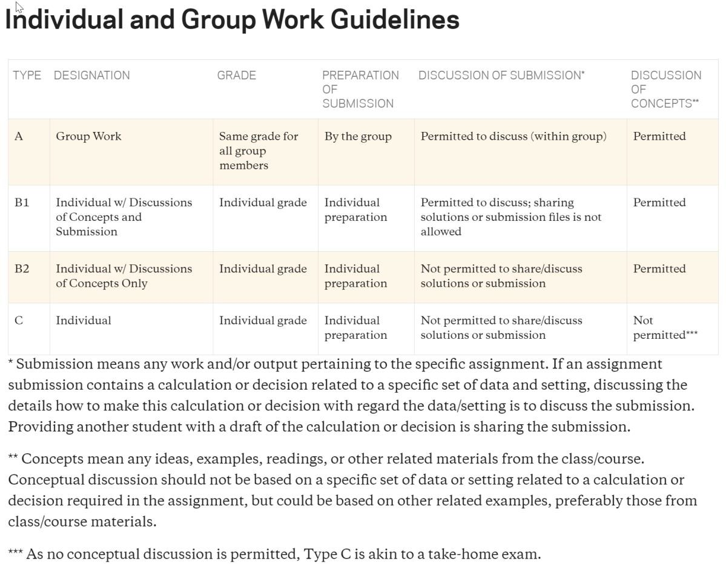

Class Norms and Expectations:
Class Attendance/Lateness: It is expected that you will come to class on time and stay for the full period. In addition, please note that this course will apply the core course standard regarding unexcused absences. Thus, unexcused absences equal to or greater than 33% of the number of class sessions (4 classes) will result in a grade of no higher than P and unexcused absences equal to or greater than 50% of the number of class sessions (6 classes) will result in a grade of F for the course. Excused absences will follow the guidelines established by the Office of Student Affairs, including religious observance, personal, medical and family emergencies, military service, or court appearances.
Laptops and Other Electronic Devices: You should bring an individual copy of the case or problem set assignment that we will be discussing on a particular day.
Name Cards: Students should bring name cards to all in-person class sessions.

Inclusion, Accommodation and Support for Students:

At Columbia Business School, we believe that diversity strengthens any community or business model and brings it greater success. Columbia Business School is committed to providing all students with the equal opportunity to thrive in the classroom by providing a learning, living, and working environment free from discrimination, harassment, and bias on the basis of gender, sexual orientation, race, ethnicity, socioeconomic status, or ability.

Columbia Business School will make reasonable accommodations for persons with documented disabilities. Students are encouraged to contact the Columbia University’s Office of Disability Services for information about registration. Students seeking accommodation in the classroom may obtain information on the services offered by Columbia University’s Office of Disability Services online at www.health.columbia.edu/docs/services/ods/index.html or by contacting (212) 854-2388.

Columbia Business School is committed to maintaining a safe environment for students, staff and faculty. Because of this commitment and because of federal and state regulations, we must advise you that if you tell any of your instructors about sexual harassment or gender-based misconduct involving a member of the campus community, your instructor is required to report this information to a Title IX Coordinator. They will treat this information as private, but will need to follow up with you and possibly look into the matter.

Counseling and Psychological Services, the Office of the University Chaplain, and the Ombuds Office for Gender-Based Misconduct are confidential resources available for students, staff and faculty. “Gender-based misconduct” includes sexual assault, stalking, sexual harassment, dating violence, domestic violence, sexual exploitation, and gender-based harassment. For more information, see http://sexualrespect.columbia.edu/gender-based-misconduct-policy-students.

