FOR BIDBING PURPOSE ONLY

Management Division Core Course B7011

Leadership and Organizational Change

EMBA NY

Summer 2022

Professor Paul Ingram
Email: pi17@gsb.columbia.edu

CONTENTS
Course Overview Page 2
Course Format Page 3
Course Requirements and Assignments Page 4
Class Data Use for Research Page 9
Class Schedule and Topics Page 10
Summary of Class Assignment Deadlines Page 20
Teaching Assistant Page 21
Suggested Books Page 22
Professor Ingram’s Biography Page 23

Required Course Material

All reading material and links to Qualtrics can be found on Canvas https://canvas.gsb.columbia.edu/.

Course Overview and Objectives

The goal of this course is to enhance your skills for leading yourself, other people, and organizations. The course is designed as the first step on your academic and professional journey here at Columbia Business School. Our goal is to help you build your leadership toolkit and facilitate your ability to take charge of your own careers. The twin themes of the course are: (1) developing, managing, and leading yourself and others around you and (2) cultivating a thriving career for oneself.

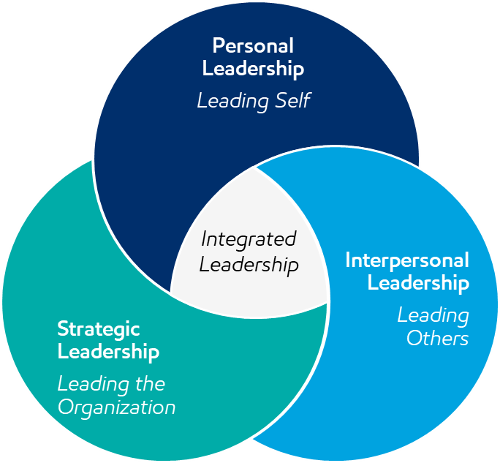

Leaders help others. However, you have to lead yourself before you can hope to influence others positively, so we begin with personal leadership, specifically how you can cultivate a growth mindset; how you can identify and be guided by your values, and how you can motivate yourself. Motivation is a bridge to the second theme of the course, interpersonal leadership. Here we consider how you can manage interactions, understand others, build relationships, and structure team processes to obtain better outcomes. The third theme of the course is about leading the organization to deliver on its strategy. This involves organizational design, building and sustaining the organizational culture, and managing effective organizational change. Together, these three elements of the course present a guide to integrated leadership that will serve you now and throughout your career.

Although developing these skills requires time, experience, and commitment, this course sets the stage for you to identify where you can get the most leverage to enhance your leadership toolkit. The course provides fundamental tools from experience and the behavioral and social sciences that will improve your ability to analyze people, team, and organizational dynamics and take robust action for more successful outcomes. You will have the opportunity to hone these skills both in and outside the classroom during your time here at Columbia Business School and as you continue throughout your career.

Course Format

Each day we will focus on a particular set of leadership skills and challenges. Our goal will be to distinguish between effective and ineffective techniques. We will accomplish this through experiential exercises, case discussions, exploration of your own experiences, and application of broader lessons to produce entrepreneurial thinking where theory can meet practice.

Individual Participation: You are expected to come to all classes on time, prepared to make comments and ask questions that add to the understanding (your own and your classmates’) of course materials. You are also expected to follow the CBS honor code, and norms about professional conduct in the classroom.

Readings: You are expected to read all the materials before the session for which they are assigned. You should ask yourself these questions as you read: (a) Do I understand the principles of this material? (b) What are its implications and how would I apply this as a leader?

Group Participation. Your learning groups have an important role in your week-to-week experience in this course. You should have established meetings with your study group every week. Besides working on assignments, you should discuss readings and cases in your group before they are covered in class. Your study group is your front-line for understanding the material.

The class experience is key to your growth in LOC. Engaging in class through your full participation in the exercises and case discussions, asking thoughtful questions, and providing insights from your own experiences, will allow both you and your classmates to succeed.

Course Requirements and Assignments

Grade Components:

Your quantitative grade is composed of:

- 10 Leadership Dashboard Assignments 30%
- Participation and Reflection 30%
- Backward-Looking Story 5%
- Learning Group Assignment: Teleswitches Change Simulation 5%
- Final Exam 30%

As will be explained in your EMBA orientation, all core classes at CBS use a grading curve, which will be applied to the class based on the quantitative grade.

Leadership Dashboard (30%)

The leadership dashboard consists of ten prompts, one per class session, that are designed to help you engage course material and prepare to benefit optimally from each class session. You can access and complete each assignment through Canvas. Note that some of the dashboards are pre-class (preparation, due before the assigned class session) and some of them are post-class (follow-up, due after the class session). Pre-class dashboards are due at the very end of the day before the class session. Post-class dashboards are due at the end of the Thursday following the class session.

The dashboards are each worth three grade points (except the alignment analysis for dashboard number 5, which is worth 3 points). The grading scheme is: “check +” 3 points; “check” 2 points; “check-“ 1 point; “unacceptable” 0 points.

Late dashboard assignments within one hour of the due date receive a 0.1 point penalty; late assignments within one week of the due date receive a 0.5 penalty; dashboard assignments will not be accepted more than one week after the due date.

Participation and Reflection (30%)

You are expected to attend and actively participate in all classes. I grade class participation with “participation points” which do not correspond directly to grade-points (e.g., you may receive more than 30 participation points using the formula explained below), which are then converted to a grade amounting to 30% of the overall course grade.

Part of participation is presence in the class and support of mutual learning, for example in exercises and directed discussions with your classmates during the session. It will be harder for me to evaluate presence in the online format we are using this term, so I’m going to do this with a number of “pulse” surveys embedded in each class session using Poll Everywhere. These will be graded simply for completion, and I’ll be permissive if you miss one or two during a session given the challenges of the zoom format. So, for example, if there are three “pulses” in a class session, I might expect you to complete at least two of them; if there are six “pulses” I’d look for you to complete at least five. Presence in each class session will receive two participation points, and you will get all of them if you complete a threshold level of pulses.

Contributions to class discussions are another key element of participation. This is really based on quality over quantity. One keen observation every class will earn the highest grade, while a number of unhelpful observations will earn a low grade. Contributions to class discussions are worth as much as two participation points per class session. Contributions to class discussions are enhancements to the learning of your classmates, and therefore cannot be “made up” if you miss class sessions.

Your timely completion of class surveys will also receive one participation point per survey.

Missed Class Sessions & Bonus Participation Points. LOC is much better live! But if you have to miss a session, you can recover participation points by (a) watching the session video; and (b) creating an asynchronous contribution that will be valuable to your classmates.

An asynchronous contribution will typically have this form:
- A link to an article or website that provides insight, advice, or a tool that builds on the session content (so, you should watch the session video before you develop your asynchronous contribution!);
- A video starring you that explains:
  - The key insight, advice or tool you are highlighting;
  - How you have used it or intend to use it;
  - What you think your classmates might do with it.
Anything that meets the above criteria can simply be posted to the session’s blog-site; you don’t need any approval to post. Asynchronous contributions of other forms will be considered if you run them by me first. Generally they will be approved if they represent sufficient effort on your part (e.g., an hour—not unreasonable given that actual participation in class takes three hours!) and create potential benefit for your classmates.

If you missed a class completely, a qualifying asynchronous contribution will receive three participation points—that is what you would get by attending class; completing all of the polls, and making one useful comment in a class discussion.

If you attended a class and would like an opportunity to improve your participation, you can submit an asynchronous contribution and will receive one bonus participation point (presumably you would have at least received two for being in class and completing polls).

I am going to create a blog-site for each class session were asynchronous contributions can be posted, and viewed by classmates.
Reflection refers to the process of abstracting, summarizing, and personalizing each class session, after the class. This is the fundamental tool to enable you to retain your experiences and learnings from the class, so that they will help you succeed in the future. There is a video on canvas under the reflection assignment that presents my advice on how to do effective reflection. You should spend twenty minutes after every class session reflecting on the session and recording the results in your learning journal. Record these in any way that works for you (stickers, drawings, colors, glued in slides, written notes, etc). The key is that your reflections should:
- Capture the key learnings, and ideas for applying them in a way that is abstract from the case/exercise we discussed (record insights about leadership and organization, not about Real Madrid, the Metropolitan Museum, or any context we study);
- You should translate your learning into a form that works for you, make them your own so they stick with you. For example, you could translate how the learnings from a case would translate into the specific industry or type of firm that you plan to join.
John Steinbeck said of the discipline of writing: “My brain just doesn’t want to tackle it today and if I let my brain get away with it, tomorrow it will have another excuse. My brain is very treacherous and I do not dare to give it any freedom to wander.” We want to help you to keep your treacherous brains in line, so we’re going to check that you are reflecting! We will have you submit your reflections on Canvas for the first six class sessions on June 29, and for sessions 7-10 on August 19.

Backward-looking story (5%)
This is a chance to tell the story of your own success. A very important part of the class is the opportunity to apply ideas, tools and feedback in the pursuit of your own professional aspirations. In this assignment, you begin by imagining yourself at a point in the future, where you have obtained your dream job, and then consider what got you there and allowed you to thrive in that role. The next step is to explain what you did after your LOC course at Columbia, way back in 2021, to “close the gaps” between where you were then and what you saw as necessary to achieve your dreams. In particular, think about:
- Your values;
- Your growth mindset;
- Your motivation style (promotion / prevention);
- Your social capital (network).
You don’t need to present an exhaustive treatment of all of the above inputs. You can pick the items that you see as key to your future success, and to your plan for improving your leadership in pursuit of your dreams. In other words, focus on what is important to you. The specific parts of your story should be these.
(1) A rich description of “where you are at the time of writing” (which is actually in the future!), a professional position that you aspire to in the long-term. In other words, your dream job;
(2) A description of how your values/motivation/network/mindset/leadership behaviors helped you get where you are, or to maintain your dream job;
(3) A reflection of challenges you saw when you analyzed your values/motivation/network/mindset/leadership behaviors during your Leadership and Organizational Change class. What was missing from your repertoire then which was necessary to achieve your professional dreams?
(4) An explanation about what you did to establish or leverage your ideal values/motivation/network/mindset leadership behaviors, starting from the time of your MBA and going through the present (again, that will be in the future!). Also note challenges you encountered in your effort to improve yourself, and explain how you overcame them. Be concrete describing your actions.

The backward-looking story will be 500 words and is due through Canvas on August 24.

Teleswitches Change Simulation (5%)

This is a group assignment, and you will submit one submission as a learning group. Read the accompanying case, and complete with your learning group the change simulation (which will be made available on Canvas).

By August 1, you will submit on Canvas (one per learning group, not necessary for each individual member to submit) a summary of your work represented by four powerpoint slides:

- A cover page identifying your learning group number and names.
- A page representing in summary form (bullet points) your strategy created BEFORE the simulation. The case explains what a strategy should represent.
- A screen shot of your score (the graphic, explained in the case) at the end of the simulation.
- Three take-aways about successful organizational change processes that you discerned from the simulation experience. These should be general principles that you could apply elsewhere (not specific to Teleswitches).

The grade on the assignment will be based on a good faith effort at the above, but won’t depend on your score in the simulation. The best way to learn from a simulation is to try to create a success, but you will get full points for the assignment if your submission is complete, even if your simulation score is low.

Final Examination (30%)

The final will be two hours. There will be a multi-day period at the end of the course and you will be able to do the exam at any time in that period. The exam has a very specific goal in this course. It is designed to emphasize that, although solving organizational problems has a heavy dose of “art”, there is also some “science.” While other parts of the grade—the dashboards, self-assessment paper, class discussion, etc.--require you to demonstrate your grasp of complex problem solving, the exam is just about the facts. It will consist of up to thirty discrete choice questions regarding specific practices that make organizations and the people in them more or less effective. The questions will be precise, of the type “if an organization does X, under these conditions, what will be the effect on its performance (e.g., profitability, growth, survival).” The questions will be based on specific research evidence that is discussed throughout the course, in class, in the readings, or both. There will be specific right and wrong answers to each question, so you will not succeed simply by relying on common sense. Instead, you will have had to attend all class sessions, complete assignments and readings, and learned the relevant material on creating effective organizations and thriving within them. There is a practice exam available on the course web page. You should consult it early in the course so you’ll know what to expect from the exam. We have a review session scheduled for the end of the semester. At this session I’ll discuss the practice exam and answer any exam-related questions.

Class Data Use for Research

Many of the learning points in this course have been developed and refined through research based on previous classroom experiences and surveys. Just as prior students have made this course possible by sharing their experiences and survey responses, you have the opportunity to contribute to the education of future students by sharing your own. If you consent to allow your responses (including those from the leadership multi-rater feedback activity, negotiations exercises, and from other exercises and surveys in this course) to be used for research purposes and for future refinement of course materials, your information will be kept strictly confidential. Any information derived from this research that would identify you will be treated confidentially and would not be voluntarily released or disclosed without separate consent.

This research takes place under the Columbia University IRB Protocol for “How do personnel values affect individuals” (protocol number AAAR4951). Research data under this protocol is treated confidentiality and anonymously, however the following individuals and/or agencies will be able to look at and copy your research records:

- The investigator, study staff and other professionals who may be evaluating the study
- Authorities from Columbia University, including the Institutional Review Board ('IRB')
- The United States Office of Human Research Protections ('OHRP').

The Principal Investigator for this protocol is Professor Paul Ingram (pi17@gsb.columbia.edu, 212-854-2740). There are no foreseeable risks to you and the proposed research does not present any additional risk beyond what you are already doing as part of the course. The benefits to you of the surveys and experiences that are potential inputs to research are to learn more about yourself as a leader and to guide your own leadership improvements. Classroom debriefing aims to help you learn not only from your own experience but also from the experience of classmates.

Your participation is voluntary and you may withhold your materials from research purposes at any time without an effect on your course grade. If at any time you have comments regarding the conduct of this research or questions about your rights as a research participant, you should contact the Columbia University Institutional Review Board by email at askirb@columbia.edu or by phone at 212-851-7040. If you do not want your responses and outcomes for exercises and surveys in this course used for research purposes, please notify the instructor.

LOC Course Schedule

May 10, 2021
Session 1: Growing as a Leader

Assignments Due in Preparation for Class:

- Read: Time to Think, Kevin Toth
- Complete: pre-class survey: A Qualtrics survey is due before class begins. This provides some input that we will use in subsequent class sessions. Access the survey on canvas.

Objectives for Today’s Session:
- Consider our own strengths and weaknesses as a leader
- Identify your near and longer-term leadership goals
- Develop tools to improve over time as leaders with concerted effort

“We can transcend the script of a pre-defined story, and pave the way for the future that we design. We just need to tap that power, that conviction, that determination within us.”
-Robert F. Smith, CEO Vista Equity Partners, CBS ‘94

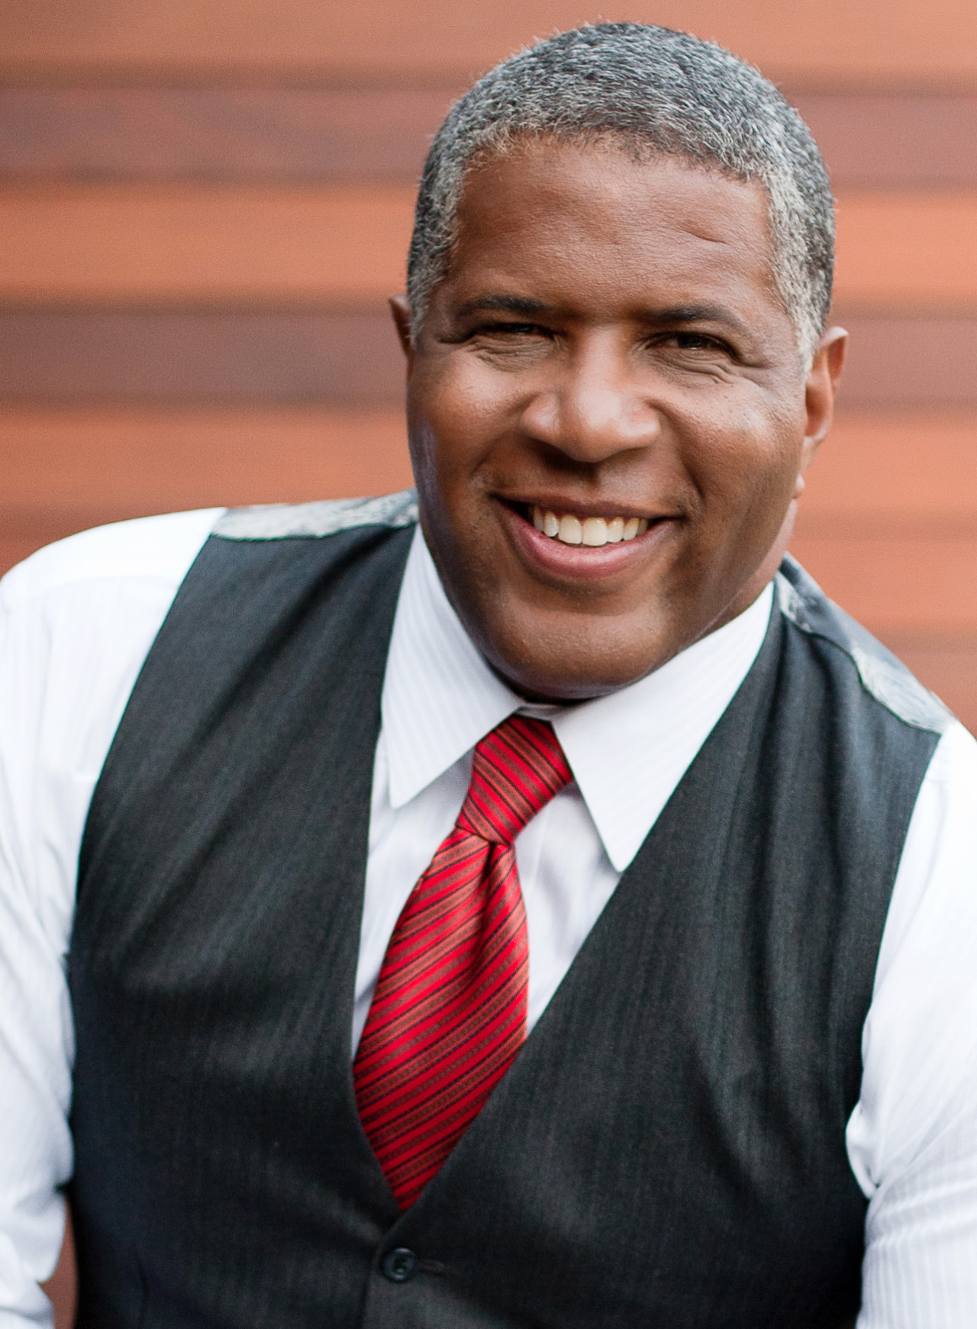

LOC Course Schedule

May 14, 2021
Session 2: Leveraging Your Values for Leadership

Assignments Due in Preparation for Class
- Read: Ingram: "Leading by your values"

Objectives for Today’s Session:
- Identify the role of values for improving self-leadership, relationships, and team and organizational performance
- Build a tool that allows you to leverage your own values
- Practice your tool to improve important relationships and an important decision

“Your beliefs become your thoughts, Your thoughts become your words, Your words become your actions, Your actions become your habits, Your habits become your values, Your values become your destiny.”
-Mahatma Gandhi

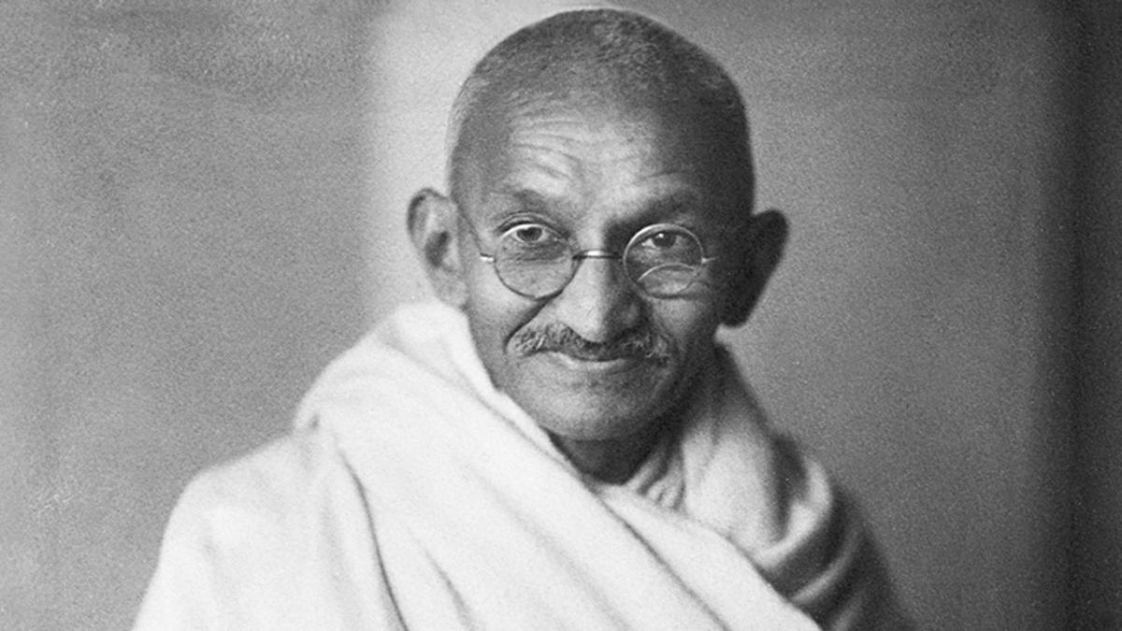

LOC Course Schedule

June 21, 2021
Session 3: Making Effective Decisions and Achieving Collective Intelligence

Assignments Due in Preparation for Class
- Read: There Will Be Oil Case
- Complete: Short survey: Submit your “drill or lease” preference through Canvas by May 12
  - Come to class ready to defend your position on the case with suitable arguments or analyses.

Objectives for Today’s Session:
- Understand the strengths and weaknesses of quantitative decision models and intuition; Identify best practices for leading group decision processes to obtain optimal decision outcomes

“What counts for most people in investing is not how much they know, but how realistically they define what they don’t know.”
-Warren Buffett, CEO Berkshire Hathaway, CBS ‘51

LOC Course Schedule

June 23, 2021
Session 4: Leading Inclusively

Assignments Due in Preparation for Class
- Complete: Identity Map in Dashboard 4, materials available on Canvas
- Read: Galinsky, A. D., Todd, A. R., Homan, A. C., Phillips, K. W., Apfelbaum, E. P., Sasaki, S. J., ... & Maddux, W. W. (2015). Maximizing the gains and minimizing the pains of diversity: A policy perspective. Perspectives on Psychological Science, 10(6), 742-748.

Objectives for Today’s Session:
- Discuss strategies for building and maintaining an inclusive cluster culture
- Discuss how to lead and be a team member in diverse organizational environments

“When we listen and celebrate what is both common and different, we become a wiser, more inclusive, and better organization.”
— Pat Wadors, CHRO at ServiceNow, former Head of HR at LinkedIn

LOC Course Schedule

June 24, 2021
Session 5: Negotiating for Value

Objectives for Today’s Session:
- Understand the different bases of interdependence that define a negotiation’s structure
- Identify strategies and best practices for creating value for yourself and others through negotiation

“The most common way people give up their power is by thinking they don’t have any.”
-Alice Walker, Novelist and Pulitzer Prize Winner

LOC Course Schedule

June 25, 2021
Session 6: Organizational Alignment

Guest Speaker
On June 17 at 5:30 PM we will have a guest speaker, Jose Almeida, CEO of Baxter International. Since this is outside scheduled class time, attendance is not required, but will be rewarding as this is a topic that will influence your leadership and career success. Attendees who complete polls in the session will receive two “bonus” participation points. If you can’t attend live, but watch the session video, you can complete an asynchronous assignment for two bonus participation points.

Assignments Due in Preparation for Class
- Read: Alignment: How Effective Organizations Really Work.
- Complete: The pre-session dashboard for this class, based on the above reading.
- Read: Real Madrid: Alignment on the Field and Off. Be prepared to discuss the questions at the end of the case.

Objectives for Today’s Session:
- Identify the universal principles of organizational design
- Introduce a framework that can be used to analyze organizational performance, and direct attention to design changes that will improve performance
- Identify elements of adaptive teams and organizatons

“We are adaptive rather than disordered.”
-Bonnie Badenoch, PhD

LOC Course Schedule
August 8, 2021
Session 7: Motivating Yourself and Others

Assignments Due in Preparation for Class
- Complete: Gleam motivation survey; instructions on Canvas
- Read: Your motivation report produced by the Gleam Survey

Objectives for Today’s Session:
- Identify the roles of intrinsic vs. extrinsic motivation
- Understand the dimensions of our own motivational systems
- Learn and practice situational leadership tools to align motivation of ourselves and others to perform better

“Motivation comes from working on things we care about. It also comes from working with people we care about.”
― Sheryl Sandberg, CFO Facebook

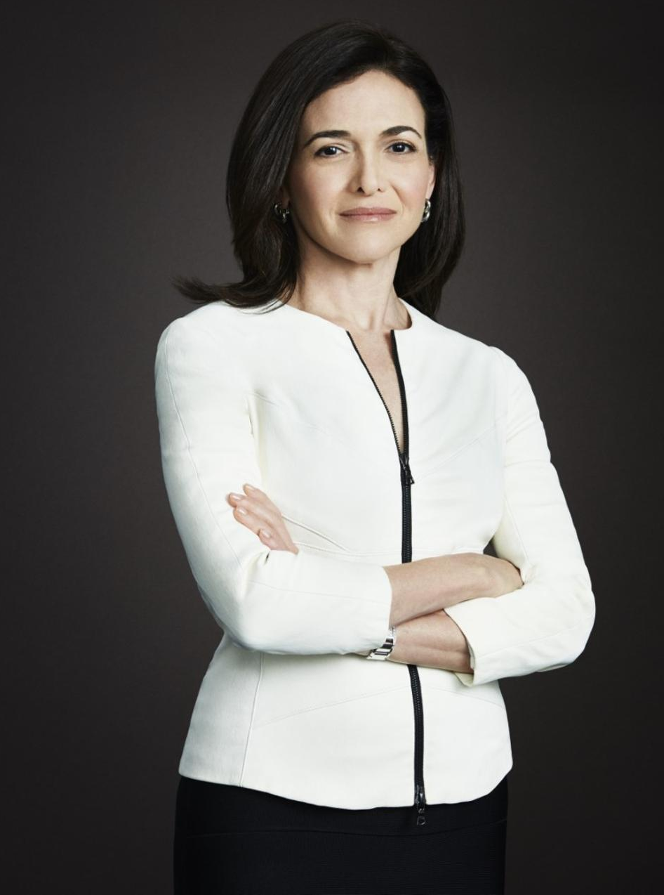

LOC Course Schedule

August 10, 2021
Session 8: Social Capital for Organizations and Careers

Assignments Due in Preparation for Class
- Complete: the GLEAM Network Assessment; produce your report
- Read: your GLEAM Network Assessment Report
- Read: Claude Grunitzky Case. Be prepared to discuss these questions:
  - How successful has Claude been as an entrepreneur so far? To the extent he has been successful what, sources of success has he employed?
  - What are the strengths and weaknesses of his current network? What advice would you give him regarding how to best leverage his network now that he is launching True Africa?
  - What network techniques does he demonstrate that you could use effectively to build and maintain your network?

Objectives for Today’s Session:
- Understand how different network structures produce different performance outcomes
- Identify best practices for building and maintaining social capital
- Begin planning action steps to improve your own professional network

“Real networking is about making other people successful.”
-Irina Benomovich (CBS EMBA 2019) CFO, Caira Surgical

LOC Course Schedule

August 11, 2021
Session 9: Organizational Culture

Assignments Due in Preparation for Class
- Read: The Evolution of Change at the Metropolitan Museum of Art. Be prepared to discuss the assignment questions at the end of the case.
- Read: The New Analytics of Culture: What email, Slack, and Glassdoor reveal about your organization. Matthew Corritore, Amir Goldberg, Sameer B. Srivastava, HBR.
- Complete: The pre-session dashboard for this class

Objectives for Today’s Session:
- Understand the role of culture for organizational and employee performance
- Identify tools that leaders have to shape organizational culture

“Know your company, know what the culture is, and align to that culture. If you can't align to that culture, get yourself out of there.”
-Sallie Krawcheck, CEO Ellevest and Former President of Global Wealth & Investment Management, Bank of America, CBS ‘92

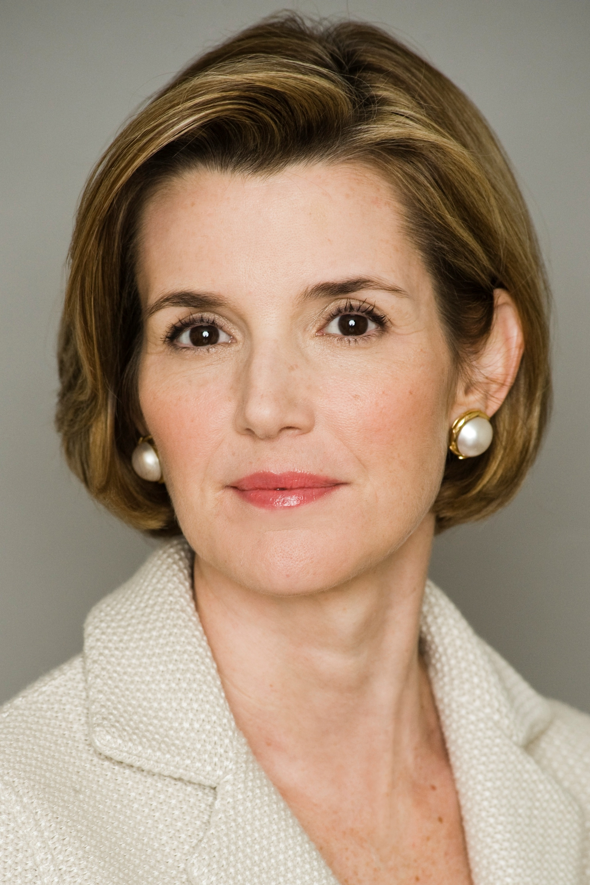

LOC Course Schedule

August 13, 2021
Session 10: Leadership in Transformative Times

Assignments Due in Preparation for Class
- Read: Implementing Change at Teleswitches, complete the simulation as a learning group and complete and submit the group assignment on Canvas.

- Read: Primer on Change: DVP > C

- Watch and engage Operation Tomodachi Case online through Canvas; Modules 1-5. Be prepared to answer these questions:
  - How should the CO navigate the “fog of war” that exists when requests for assistance are not officially approved by DoD?
  - How would you handle the first round of meetings between the Japanese MLCs (these took place before the evacuation order). Make a plan for conducting the meetings, and be precise about what you will ask and say.
  - What should the CO say to the assembled sailors, marines, soldiers, US civil servants and Japanese MLCs upon hearing word of an evacuation?

- Complete: the pre-session dashboard for this class, based on the Operation Tomodachi case

Objectives for Today’s Session:
- Consider what leaders need to do to prepare and lead optimally at inevitable moments of crisis
- Identify the necessary elements of every successful organizational change
- Examine best practices for the process of producing organizational change

“The only safe ship in a storm is leadership.”
Faye Wattleton, Founder of the Center for the Advancement of Women, CU ‘67

Summary of Class Assignment Deadlines

Assignment | Deadline
Pre-Term Survey | May 7
Dashboard 1 | May 22
Dashboard 2 | May 29
Dashboard 4 | June 18
Dashboard 6 | June 16
There Will Be Oil Survey | June 19
Learning Journal Check | June 29
Dashboard 3 | June 30
Dashboard 5 | July 15
Dashboard 9 | July 22
Gleam Motivation Survey | July 31
Group Submission: Teleswitches | August 1
Gleam Network Survey | August 3
Dashboard 10 | August 6
Dashboard 7 | August 18
Learning Journal Check | August 19
Dashboard 8 | August 21
Cluster Social Capital Survey | August 21
Backward-Looking Story | August 24
Final Exam | TBA

LOC Teaching Assistants

TAs
Sophie Cho:
SCho21@gsb.columbia.edu

Jean Oh:
Joh22@gsb.columbia.edu

LOC Recommended Readings

I’m often asked for recommendations for books that support the course concepts. Here are some good ones. The topics will be clear from the titles, or I’ve noted the topic.

Cable, Dan. (2018). Alive at Work! Harvard Business Review Press.

Cialdini, R.B. (2006). Influence: The Psychology of Persuasion. Harper Business.

Ferrazi, K. (Never Eat Alone. Random House. (Network building).

Fisher, R. and W. Udry (2011). Getting to Yes. Penguin Group (integrative negotiation).

Gentile, M. C. (2010). Giving Voice to Values. Yale University Press.

Gladwell, M. (2002). Blink and The Tipping Point (2005). Time Warner Book Group. (Blink is about intuition; tipping point is about change).

Hackman, J.R. (2002). Leading Teams: Setting the Stage for Great Performances. Harvard Business Review Press.

Halvorson, H.G. and E.T. Higgins (2013). Focus: Use Different Ways of Seeing the World for Success and Influence. Penguin Group (Motivation, promotion and prevention).

Heath, C. & Heath, D. (2010). Switch: How to Change Things When Change Is Hard. Crown Business.

Hoffman, R., & Casnocha, B. (2012). The Start Up of You. Crown Publishing Group.

Iyengar, S. (2010). The Art of Choosing. Twelve.

Kahneman, D. (2011). Thinking Fast and Slow. Macmillan. (Decision making).

Kotter, J.P. (2012). Leading Change. Harvard Business Review Press.

Mandis, Steven. (2017). The Real Madrid Way. Dallas: BenBella Books (Culture and Alignment)

Nadler, D., M. Tushman (1997). Competing by Design. Oxford. (Organizational design and alignment).

Stone, D. Patton, B. Heen, S. & Fisher, R. (2010). Difficult Conversations: How to Discuss What Matters Most. Penguin Books. (Conflict management).

Professor Ingram’s Biography

Paul Ingram is the Kravis Professor of Business at the Columbia Business School, and Faculty Director of the Columbia Advanced Management Program, Columbia’s flagship program for senior executives from around the globe. His PhD is from Cornell University, and he was on the faculty of Carnegie Mellon University before coming to Columbia. He has held visiting professorships at Tel Aviv University, Shanghai Jiao Tong University and the University of Toronto.

The courses he teaches on management and strategy benefit from his research on organizations in the United States, Canada, Israel, Scotland, China, Korea and Australia. His research has been published in more than sixty articles, book chapters and books. His publications have received numerous distinctions, including the Gould Prize from the American Journal of Sociology, and best paper awards in the areas of Organization and Management Theory, and Collective Behavior and Social Movements. Ingram's current research examines the intersection between culture and social networks. Recent papers investigate questions such as the role of value similarity to foster business networks, determinants and outcomes of individuals’ fit in organizational cultures, and influences on ethical decision making.

He has served as President of the College of Organization Science of the Institute for Operations Research and Management Science (INFORMS). He is currently an Associate Editor for Academy of Management Discoveries, and has served as a consulting editor for the American Journal of Sociology, a senior editor for Organization Science, an Associate Editor for Management Science and on the editorial boards of Administrative Science Quarterly and Strategic Organization.

Paul’s undergraduate degree is from Brock University where received the Governor General’s Award as the top graduating student. In 2004 he received the Distinguished Graduate Award from Brock’s Faculty of Business. At the Columbia Business School, Paul has received the Dean’s Award for Teaching Excellence, won the Commitment to Excellence Award, voted by graduating EMBA students six times, and thrice been chosen by graduating EMBA students to deliver the keynote speech at their commencement ceremony. He has consulted on issues of leadership, organizational design and strategy to leading companies in the finance, health care, insurance, energy, arts, education, and consumer products industries.

